1.Creating Tables

<!DOCTYPE html>

<html lang="en">

<head>

    <meta charset="UTF-8">

    <meta http-equiv="X-UA-Compatible" content="IE=edge">

    <meta name="viewport" content="width=device-width, initial-scale=1.0">

    <meta name="this is a table" content="it was about product listing">

    <title>Tables</title>

</head>

<body>

    <h1>Product Listing :</h1>

    <h2>men's clothing</h2>

    <!--

        <table>

            <tr>

                <th></th>

                <td></td>

            </tr>

        </table>

        where tr=table row

              td=table column

              th=table heading

    -->

    <table border="1" cellpadding ="30px">

        <tr>

            <th>Product ID</th>

            <th>Product Name</th>

            <th>Product Description</th>

            <th>Buy Now</th>

        </tr>

        <tr>

            <td>SKU10101</td>

            <td>T-Shirt</td>

            <td>Made With Fine,

                100% Cotton

            </td>

            <td><a href="https://https://www.amazon.in/s/ref=nb_sb_noss?url=search-alias%3Daps&field-keywords=t-shirt">Buy Now</a></td>

        </tr>

        <tr>

            <td>SKU10202</td>

            <td>Pants</td>

            <td>Slim And Straight cut jeans</td>

            <td><a href="https://https://www.amazon.in/s?k=pants&ref=nb_sb_noss">Buy Now</a></td>

        </tr>

        <tr>

            <td colspan="4">Product From <a href="https://www.amazon.com" >Amazon.com</a></td>

        </tr>

    </table>

</body>

</html>

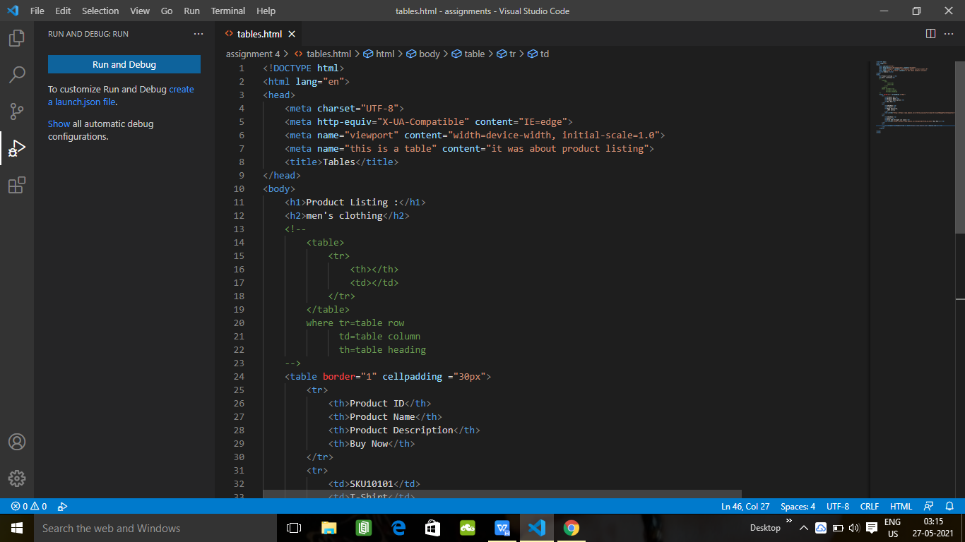

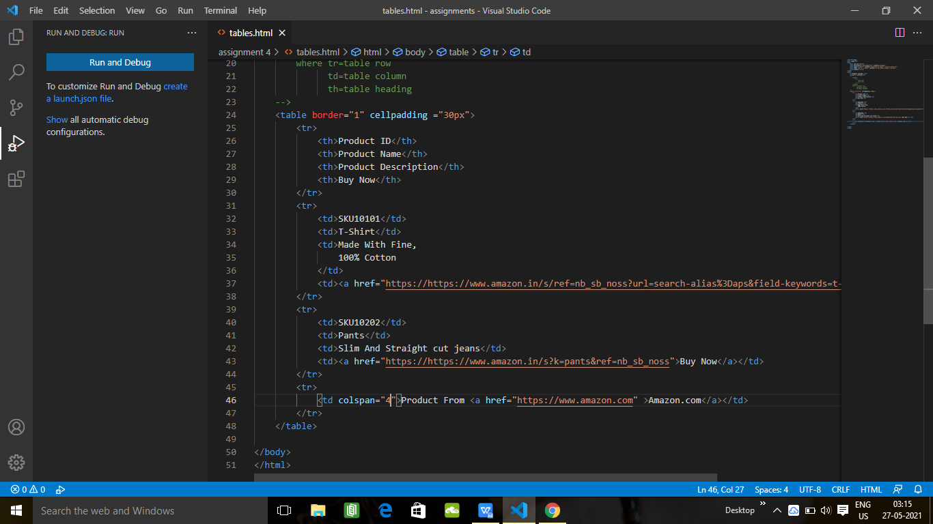

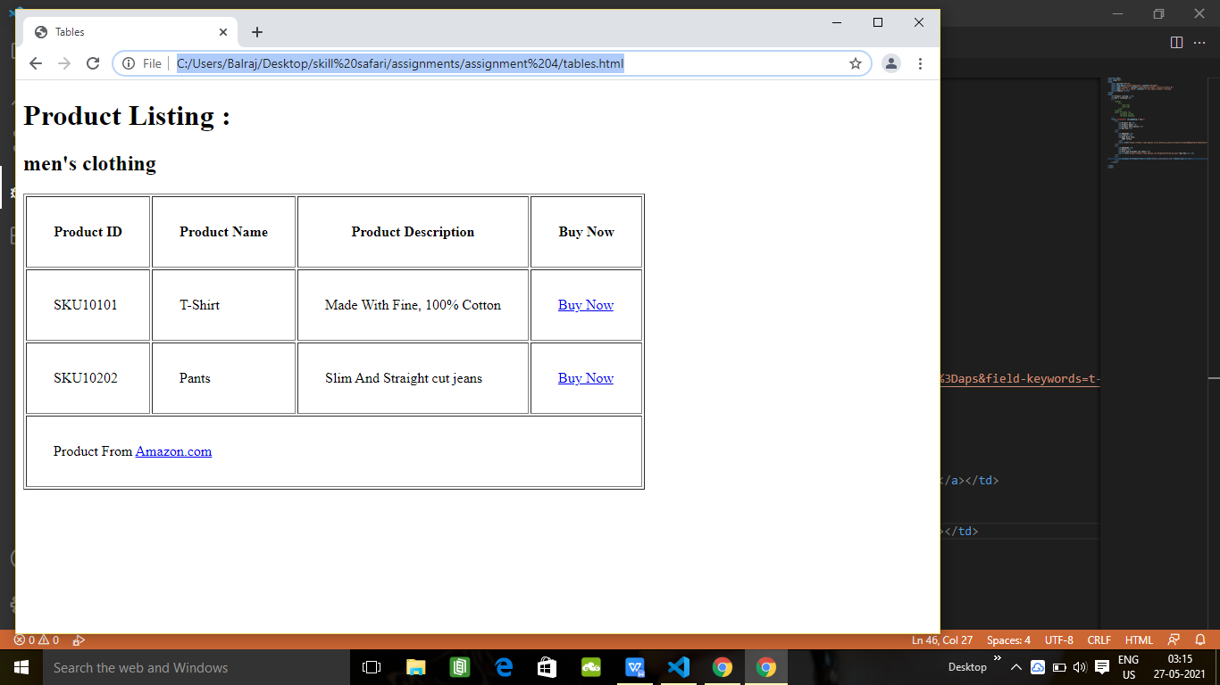

1. EMBEDDING IMAGES IN PRODUCT LISTING

<!DOCTYPE html>

<html lang="en">

<head>

<meta charset="UTF-8">

<meta http-equiv="X-UA-Compatible" content="IE=edge">

<meta name="viewport" content="width=device-width, initial-scale=1.0">

<meta name="this is a table" content="it was about product listing">

<title>Tables</title>

</head>

<body>

<h1>Product Listing :</h1>

<h2>men's clothing</h2>

<!--

<table>

<tr>

<th></th>

<td></td>

</tr>

</table>

where tr=table row

td=table column

th=table heading

-->

<table border="1" cellpadding ="30px">

<tr>

<th>Product ID</th>

<th>Image</th>

<th>Product Name</th>

<th>Product Description</th>

<th>Buy Now</th>

</tr>

<tr>

<td>SKU10101</td>

<td>

<!--embed image

<img src="images.jpg" alt="this is a image">-->

<img src="images/tshirt.jpg" alt="this is a tshirt image" width="100px" height="100px">

</td>

<td>T-Shirt</td>

<td>Made With Fine,

100% Cotton

</td>

<td><a href="https://https://www.amazon.in/s/ref=nb_sb_noss?url=search-alias%3Daps&field-keywords=t-shirt">Buy Now</a></td>

</tr>

<tr>

<td>SKU10202</td>

<td>

<img src="images/pant.jpg" alt="this is a pant image" width="100px" height="100px">

</td>

<td>Pants</td>

<td>Slim And Straight cut jeans</td>

<td><a href="https://https://www.amazon.in/s?k=pants&ref=nb_sb_noss">Buy Now</a></td>

</tr>

<tr>

<td colspan="4">Product From <a href="https://www.amazon.com" >Amazon.com</a></td>

</tr>

</table>

</body>

</html>

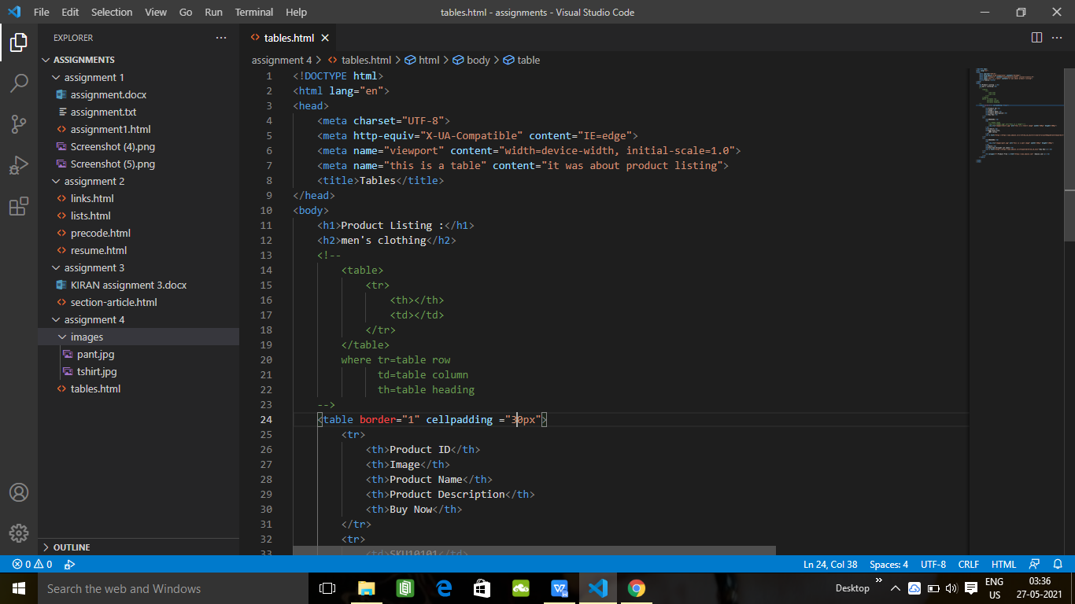

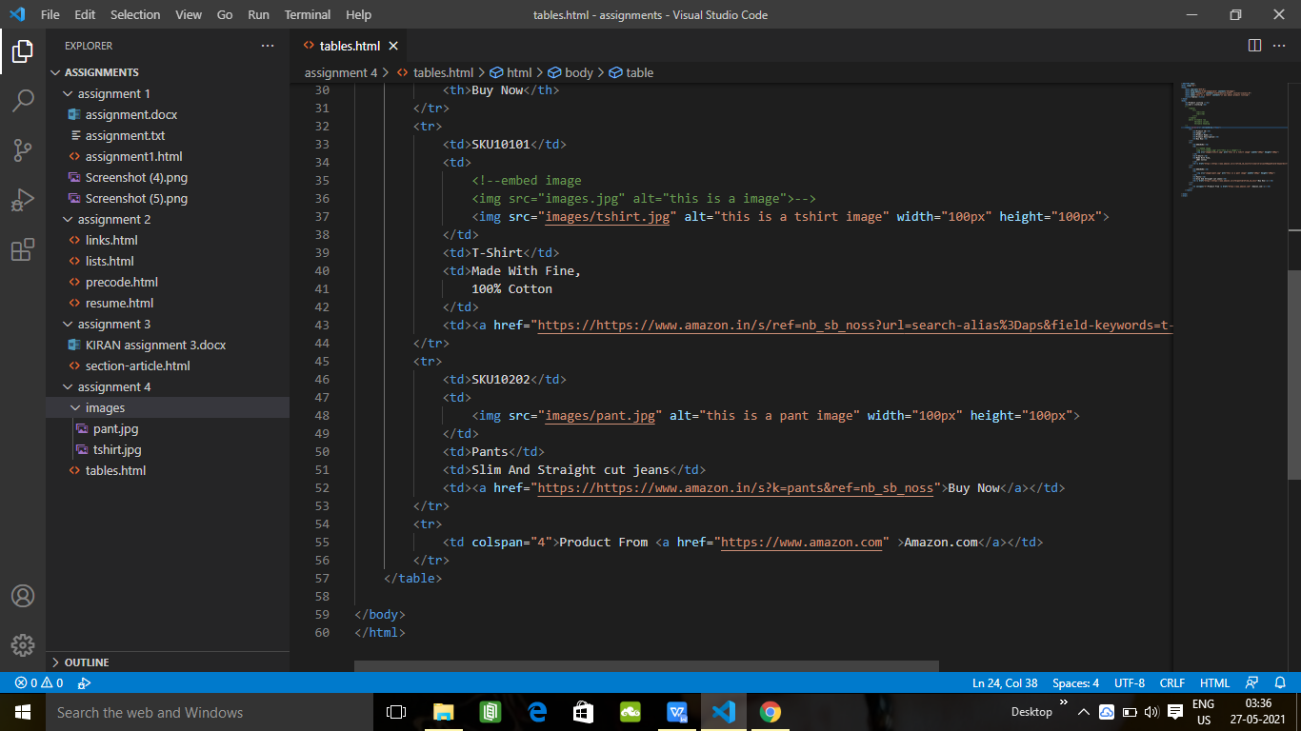

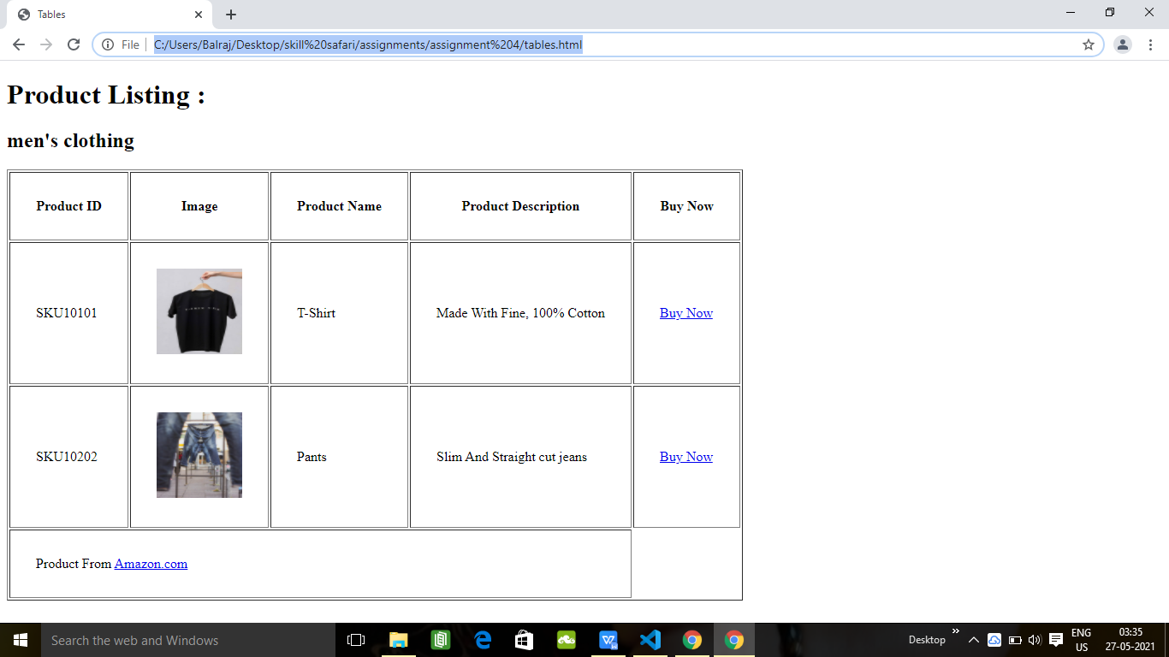

1. PROJECT - DOWNLOAD AUDIO FILES

<!DOCTYPE html>

<html lang="en">

<head>

    <meta charset="UTF-8">

    <meta http-equiv="X-UA-Compatible" content="IE=edge">

    <meta name="viewport" content="width=device-width, initial-scale=1.0">

    <meta name="Music Download Page" content="it was about Shape of you Mp3">

    <title>Tables</title>

</head>

<body>

    <h1>Shape Of You MP3 Download</h1>

    <!--

        <table>

            <tr>

                <th></th>

                <td></td>

            </tr>

        </table>

        where tr=table row

              td=table column

              th=table heading

    -->

    <!-- Embed Image

    <img src="images/images.jpg" alt="this is a image">

        Embed Audio

    <audio controls autoplay>source src="audio/audio.mp3" type="audio/mp3"></audio>-->

    <table>

        <tr>

           <td><a href="https://www.facebook.com">Facebook.com</a></td>

           <td><a href="https://www.twitter.com">Twitter.com</a></td>

           <td><a href="https://www.bing.com">Bing.com</a></td>

        <tr>

            <td colspan="2"><img src="images/images.jpg" alt="this is shape of you "></td>

        </tr>

        <tr>

            <td rowspan="2"><img src="images//download.jpg"alt="download"></td>

        </tr>

        <tr>

            <td colspan="2"><i>ED sheeran Shape Of YOu <b>NEW SONG 2017</b></i></td>

        </tr>

        <tr>

            <td colspan="2"><audio controls><source src="audio/Shape of You.mp3" type="audio/mp3">the browser supports mp3</audio></td>

        </tr>

    </table>

    <hr>

    <p>Copyrights(C) 2021. <a href="https://audiomp3.com">Audiomp3.com</a></p>

</body>

</html>

